- Go to Metro Link -> Shared reports - > 13 Cross Country Reporting > 999 Sourcing reports > Sourcing Homepage
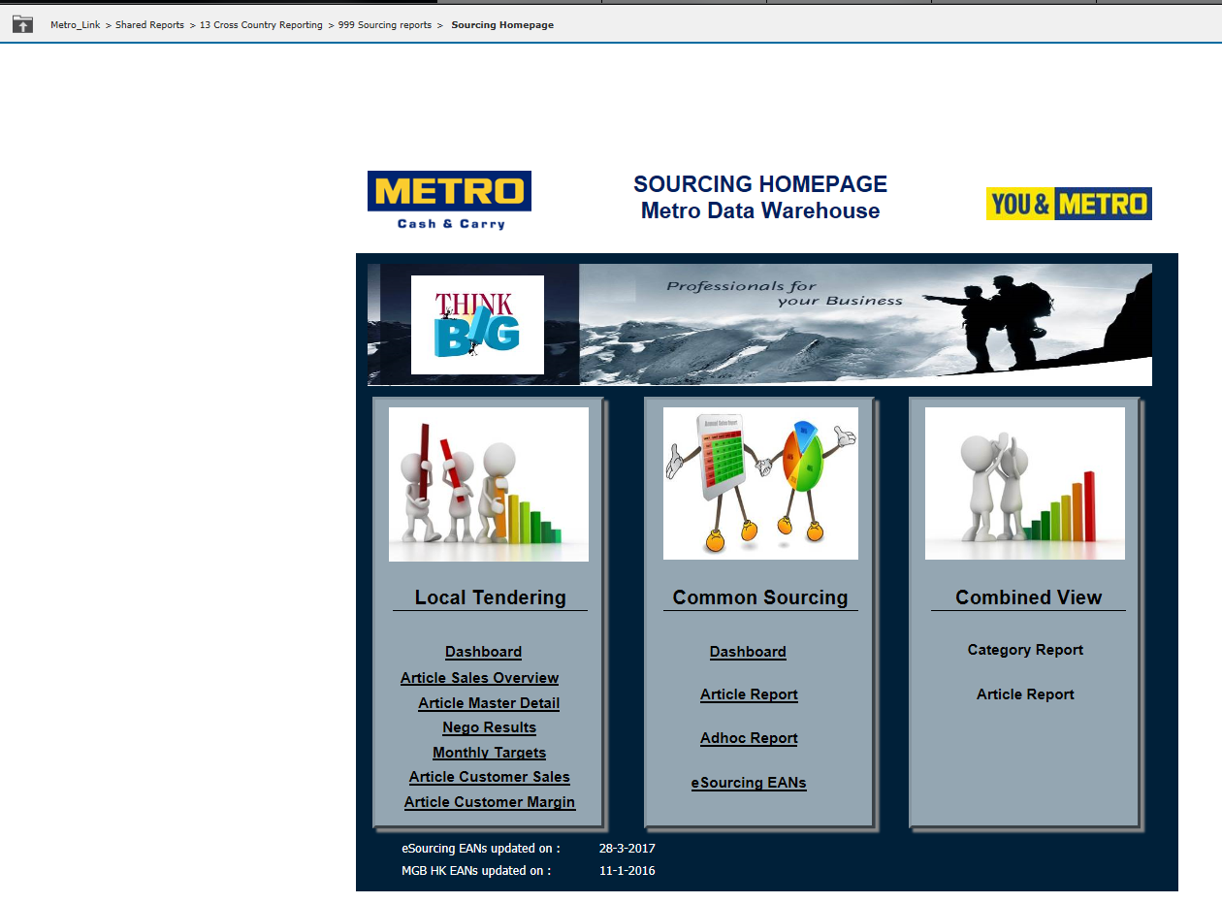

- Click on the arrow next to your name and then on “Preferences”:
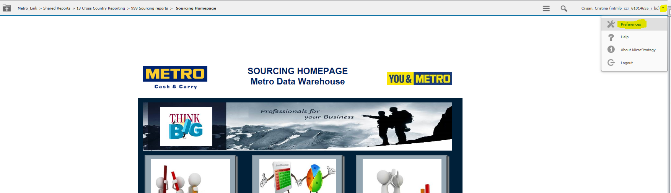
- Select as Default start page: “Last document: Sourcing Homepage”. Click on Save (left upper corner). Click Close then.
